Plato's Theory of Knowledge
Meno (circa 380 BC) and Theaetetus (circa 360 BC), Excerpts

BACKGROUND: Socratic Dialogues
- Dialectic
- Midwifery
- Open-ended search for truth

Plato, Republic (514a-521b)

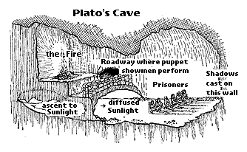

TOPIC:
KNOWLEDGE:
JUSTIFIED TRUE BELIEF?

REGARDING

- [Meno 97-99] SOME SIMILARITIES AND DIFFERENCES BETWEEN KNOWLEDGE/WISDOM (phronesis) AND OPINION (dóxa)
cf. theoretical knowledge: form (eidos)

- [Theaetetus 200-201] MORE DEFINITE DIFFERENCES BETWEEN KNOWLEDGE AND OPINION

- WHY KNOWLEDGE IS "BETTER" THAN OPINION

- Meno
  - Paradox of knowledge
  - Anamnesis (recollection): immortality of the soul
  - Phronesis and dóxa ⬅ analyze this part
  - Geometrical demonstration: Meno, "the slave boy"

- Theaetetus
  - knowledge: perception?
  - knowledge: true opinion/judgment/belief?
  - knowledge: justified true opinion/judgment/belief? ⬅ analyze this part

