Aegean Cilivizations:
Rise of Human Consciousness and
The Mytho-sociological Imagination Among
The Minoans and the Myceneans

[Minoan Civilization]
- Timeline [WH 32-3, approx. 3000-1100 BC]
- Key Background
  - Crete [WH 32] : the birthplace of Zeus (a mortal god)
    - Cf. Formative influence on Mycenaean/ancient Greek mythology
  - King Minos and Queen Pasipha; Minotaur [WH 34]
    - Fresco (flat surface, clay)
    - Allegory of divine-human relation; the “angry” god
      - Bestiality of human sexuality
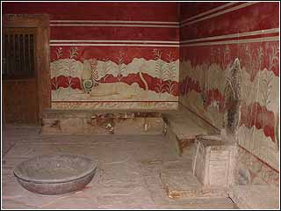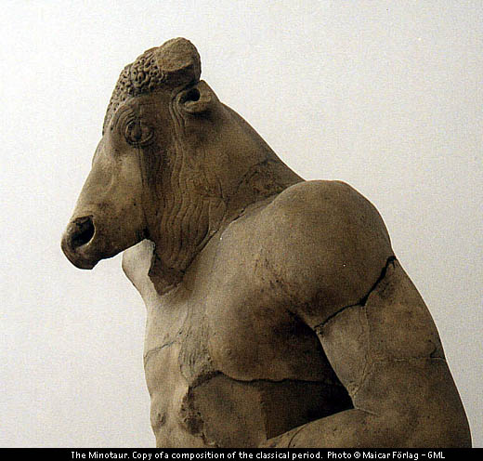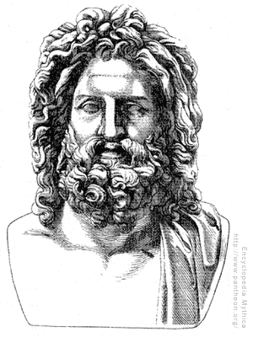

- Matriarchal and Peaceful: legendary even among the ancient Greeks

[Mycenaean Civilization]
- Timeline [WH 35, approx. 1900-1100 BC]
- Key Background
  - Peloponnesus [WH 32]: fortress places/cities such as Ashlars (Lion Gate)
  - Feudal system with a rigid class structure and gender identities; oligarchy
    - Formative influence on ancient Greek mythology/political system/ethics
      - Cf. Olympian Deities [WH 42]
- Belligerent, Hero-worshipping and Passionate

[WH 38-9]

