The “Two Worlds” of Plato

- SAME vs. DIFFERENT
- REAL vs. ILLUSORY

SAME vs. DIFFERENT [R 82-4]: Educational Equality vs. Division

Puzzle: “Equality” and “Natural” Differences

Platonic Dialectic of Sameness and Difference

- Tasks and Questions:
- First, reconstruct and evaluate Plato’s following argument/proposal:

“So the women of the guardians […] must share in war and in all the guarding of the city, and that shall be their only work. But in these same things lighter parts will be given to women than men because of the weakness of their sex.” [R 84, emphases added]

➔ To help you understand and contextualize this passage with which Book V of the Republic concludes: think about and explain:
  - Why “so”? What was/is the argument, that is, reasoning behind it?
  - Why “but”? What was/is the argument, that is, reasoning behind it?

- Now, answer this question: Is Plato “a feminist [R 81],” as Matthews and Platt seem to wish to suggest or rather, on the contrary, a sexist? [R 81] If so, what kind? If not, why not?

➔ Again to help you understand the point of this question: break down your analysis into the following three.

  - Explain your definition and understanding of these notions, feminism and sexism
  - Provide your interpretation of Plato’ position, namely, his conceptions of “nature”, “equality”, and “differences” – how he uses those notions.
  - And argue your position.

REAL vs. ILLUSORY [R 84-85]: Outside vs. Inside; Inside vs. Outside

Plato, Republic (514a-521b)

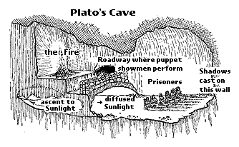
http://faculty.washington.edu/smcohen/320/cave.htm

