Judaism:
Hebraic Iconoclasm, Diaspora and the Promised Land

- Timeline [2000 BC–AD 70, WH 146]
  - The Hebrews in Canaan [-1500 BC]; Egypt [-1250 BC]; back to Canaan [Cf. Exodus]
    - Canaan: the Promised Land (of milk and honey): now Israel and Palestine
    - Formation of the Tradition of “Desert-Thinking”

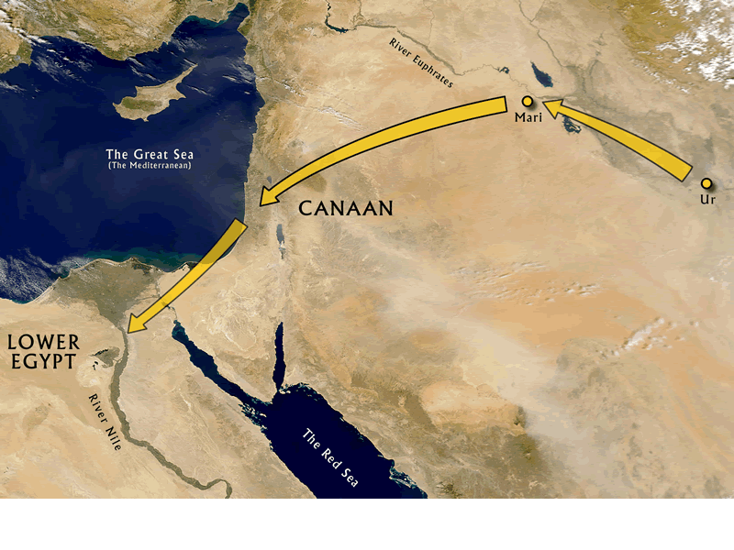 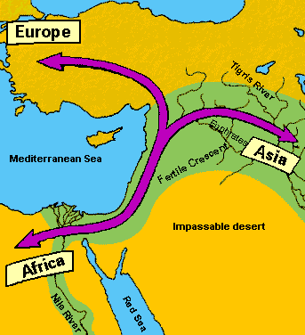 Judean Wilderness cf. map [WH 146]

- Key Background: Textual and Nomadic Culture

  - Divine Promise: The Ten Commandments & Mosaic Law [WH 146-7]
    - Rise of Hebraism ( ⬅➔ Mediterranean Hellenism)
    - Ethical Monotheism (⬅➔ The Code of Hammurabi)
      - The Ten Commandments: Divine Origin of Human Law
    - Iconoclasm: Ineffable and Invisible God
      - YHWH: Yahweh (I am)
      - Synagogue
      - “Reading” (vs. Seeing) God, the word of God: Torah [152-4]
    - Messianism: Messiah (Anointed One, WH 149-50)

  - Family-Oriented Nomadism: “The Wandering Jews” [WH 149–52]
    - Patriarchal Genealogy Solidified by Matrilineal Descent System
    - Ethically-bound Families/Communities: obligation and interdiction
    - Jewish Diaspora and its integrated contribution to, as well as survival in, the Greco-Roman West; cf. The Holocaust

- Reading: Exodus 20:1-23 [R 145]
  - The Ten Commandments: “You shall not…”
  - A topic for discussion: on fear and religion – its ambiguous relationship

Moses answered the people, “Be not afraid; for God has come only in order to test you, and in order that the fear of Him may be ever with you, so that you do not go astray.” So the people remained at a distance, while Moses approached the thick cloud where God was. [R 145, My emphases]

Compare that advice with this Epicurean maxim, “we do everything we
do—to achieve freedom from pain and freedom from fear [R 100].”

