2/21/06
Leonardo da Vinci
Rediscovering/Remapping the World of the Human Mind
- Leonardo is said to of remapped the world in the renaissance period with his modern outlook on things.
  - Da Vinci changed the notion of nature through his views on many fields including artist, sculptor, architect, engineer, and scientist among other things.
  - Examples: in the field of painting da Vinci modernized the time period by using perspectives/focal points in his paintings which gave it a realistic look; he made people feel like they were in the painting by going from 2D paintings to 3D paintings. Here is an example of the focal point he uses.
  - When you compare previous Last Supper paintings with da Vinci’s, you can see that da Vinci’s painting is much more modernized. Giottos Last Supper painting is thought of as inferior to da Vinci’s since it is less dramatic, not symmetrical, no perspective, Jesus is in an odd end of the table, and there is no frontal view. On the other hand da Vinci’s painting shows that he used mathematics as he uses Jesus’s head as the focal point of the drawing, and shows perfect symmetry by having 6 disciplines on either side, there also seems to be a lot of interesting things going on in the painting that are still unexplained today.
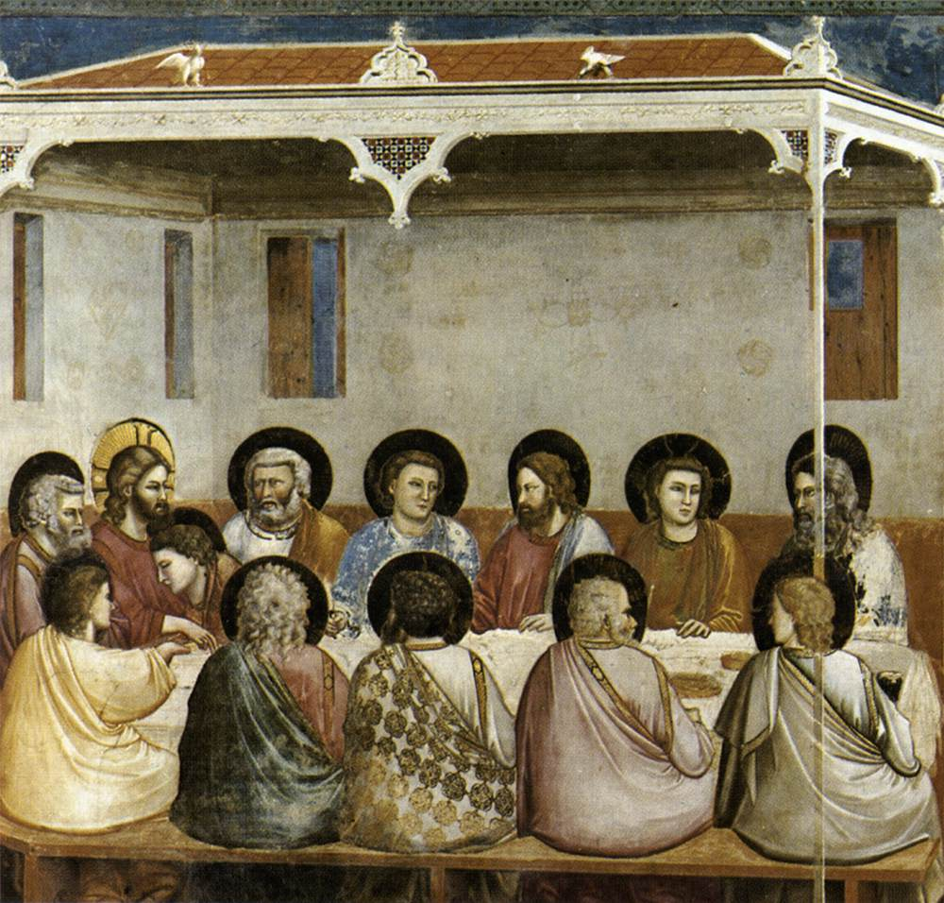
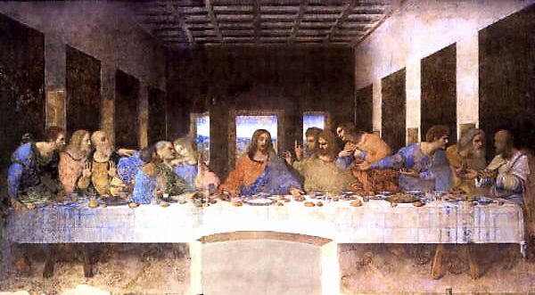
  - Another example is how da Vinci modernized medicine. In times before the Renaissance people thought of the body as a sort of sacred special thing that had to be treated with natural herbs and such. Da Vinci modernized medicine by looking at the human body as a machine, therefore since it was a machine it could be fixed like a machine.
  - Below is a picture from one of the notes from da Vinci’s notebook. This shows how da Vinci related geometry to human beings, da Vinci stated that the naval is the center point of a human and that if measured from naval to toe/finger that it is the same length which makes humans symmetrically balanced
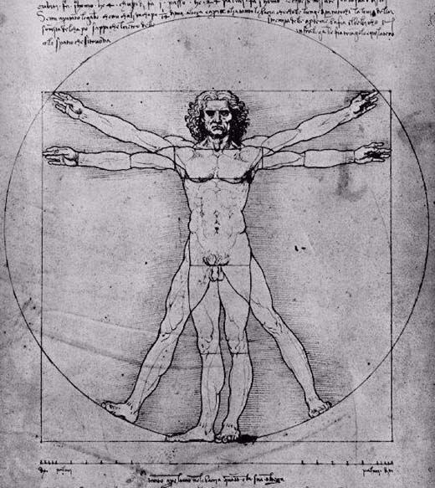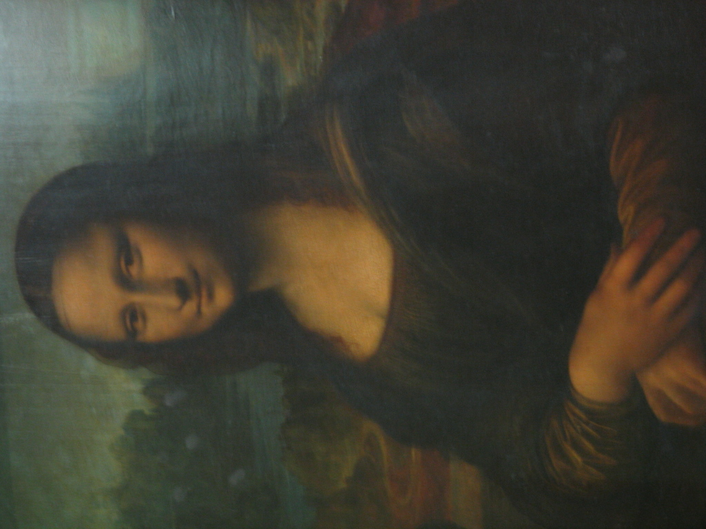
- The type of thought that helped transition into the Renaissance period is men who have a thirst to understand themselves and their surroundings.
  - This type of thought process lead to the development of all kinds of things (art, architecture, technology, etc.)
- Leonardo’s Mona Lisa is a very mysterious painting that may never be understood.
  - The portrait of a human image is a very ancient Greek thing to do
  - There is an unending line of questions about this painting: why is she smiling? Who is she? Is this a obscure self portrait of Leonardo? No body knows.
- Michelangelo and da Vinci were though of as rivals at their times
  - The most famous Michelangelo work is the statue of david
  - The statue of david shows a man in the complete nude

